April 22nd, 2012
Hi
Well. I am writing this letter in the flat. I contacted the Internet company on Thursday who told me that the internet connection is already working. So, I decided to move the computer over to check. There was no problem with the internet connection, though the simplest of operations - switching on the computer - would not as first work! So, that means for the remaining week staying in the hotel I will have to walk over here to use the computer.
Very little stuff left to transfer now. A total of 51 trolley loads has been needed (plus smaller transfers in shoulder bags) and probably just one more for remaining food and cooking utensils. I have thrown out quite a lot of stuff but probably not as much as I could or should have. For example, I still have textbooks and course notes from way back in my early university days in NZ as well as from Stanford. Still need to organise some of the stuff. Clothes were deposited in the wardrobe and books in the bookcases without sorting them out; I was more concerned that there was enough space. I will sort it all out later.
The flat is almost ready to live in also. Last week I opened an electricity account. The gas was turned on yesterday and a water supply account arrived yesterday as well. Until then, I was still able to use electricity and water, but not gas, though I have no idea who was paying for it, as all my accounts have been set to zero. Also yesterday, a guy came to fit curtain rails for the lounge and bedroom and a Venetian blind for the study. He also bored holes in the walls for three pictures - the Faculty of Education photo (which was hanging in the hotel suite) and two small pictures that we had hanging in 5B. Do you remember these - they have a red background with a circle containing artwork of traditionally-dressed Chinese/Japanese ladies? After the guy left, I had to clean up the remaining dust, even though his drill had a kind of wrapping that was able to collect a lot of the dust. The curtains may be installed this coming Friday; I hope so as Saturday is a public holiday (not sure what it is for though). Cost for the curtains is HK$1900. The cash for this I had left sitting on the table and it was there when the gas-man came!! I think the real estate agent was with him as he had the second key for the flat; after this, I found this key in the mail box. The telephone connection should also be made this coming Friday.
Nadine, amongst a pile of papers I was sorting out I came across an essay you wrote in Year 10 on the plight of Filipino domestic workers in HK. Do you remember it? I have now placed it in the one of the two large boxes labelled, 'L, G and N'.
I started swimming this past week. Difficult to fit in the swims as there has been a lot of rain and many thunderstorms during the week. Still, managed to get in three swims. When I leave the hotel, I may continue to use the hotel gym and pool rather than those here, even though it is more expensive than here (because here they have 'senior' rates). The pool here is nice,and being between the two sets of towers is shaded from the Sun, which is good for me with skin cancer). The pool season is quite short, mainly, I think, as few people seem to use it (based on what I could see looking across from the suite). However, the gym here is not very good.
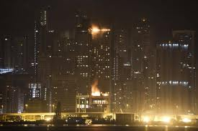
Yesterday in the early morning, there was a big fire at the 'Harbour Grand' hotel in North Point, a sister hotel to the 'Harbour' Plaza' hotel here. Started on the rood and spread to balconies and rooms on some of the floors. Fortunately, on-one was injured and everybody was able to evacuate safely. The only complaint from guests was that many did not here any alarm. Apparently, fire regulations in HK for hotels only require the alarms to operate on the the floor where the fire is plus a few above and below.
That's about it. Will now wash the (marble) floor having swept up the dust yesterday.
Cheers
PS: I notice that a lot of last year's letter dealt with ANZAC day (April 25th). Australia TV will broadcast remembrance services live first from Gallipoli then later from France. If I remember, and have no work to do, I may watch some of it. That will be in the suite. Here I have no TV and may not get one. The local broadcasters (ATV and TVB) are free-to-air, but for all the other channels, it is necessary to pay for each separately, e.g. BBC, National Geographic, Discovery are all about about $50 a month each (but need to subscribe for a whole year). With any one of these, the company gives Aus TV free! which is a channel I like.

April 24th, 2011
Hi
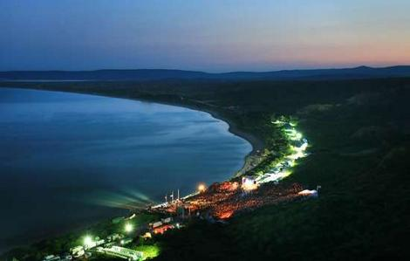
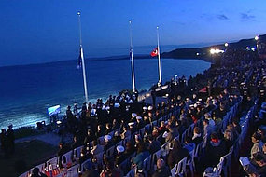
There was no letter for this weekend last year to overwrite as I was still in NZ though with only one day left. So I am overwriting the letter from two years ago. Interesting reading it first though. A lot dealt with Anzac Day which was the day before writing. This year, it is tomorrow. ABC (Aus) will broadcast the dawn service from Gallipoli as they seem to do every year now. Here it will be 10.30 am and I will probably watch it while working. After that they will broadcast a similar broadcast from somewhere in France. I wonder where the dawn service will be held in Christchurch now that the Square is still (I think) a no-go area. (The photos are from the earlier letter.) From the earlier letter I wrote: I looked up the Commonwealth War Graves Commission website for information on the Gallipoli campaign and found that they have very interesting information leaflets about the two world wars (including Hong Kong). Have a look at:
http://www.cwgc.org/document.asp?menuid=5&submenuid=24&id=5&menuname=Information%20Sheets&menu=subsub
It is fortunate I could make the above comments as there is almost nothing else. I only did exercise on two days. Am having a rest and will begin swimming tomorrow. I could have gone for a run yesterday and it was actually cooler than last week but decided the running season was over for this year.
Did you here about what is included when you get an iPhone? It has a device that tracks and stores your movements (which assumes of course that you carry the phone around with you) and then sends it to somewhere. Phones that uses Google's Android operating system have a similar device. This also sends information several times an hour to Google about what you are doing with your phone! This explains a cartoon I saw in the SCMP but didn't understand at the time; A man is arriving home very late looking the worse for wear and his wife comments “I don't need an iPhone to tell that you have had 'a long night at the office'”.
That’s about it
Cheers
Appendices: (again from the 2009 letter but decided to leave them here)
WWI produced a lot of great poetry. Here is one called “For the Fallen” (1914) by Laurence Binyon (1869-1943), most notable for the fourth stanza, which adorns numerous war memorials and is recited at services (including the Gallipoli services).
For The Fallen
With proud thanksgiving, a mother for her children,
England mourns for her dead across the sea.
Flesh of her flesh they were, spirit of her spirit,
Fallen in the cause of the free.
Solemn the drums thrill; Death august and royal
Sings sorrow up into immortal spheres,
There is music in the midst of desolation
And a glory that shines upon our tears.
They went with songs to the battle, they were young,
Straight of limb, true of eye, steady and aglow.
They were staunch to the end against odds uncounted;
They fell with their faces to the foe.
They shall grow not old, as we that are left grow old:
Age shall not weary them, nor the years contemn.
At the going down of the sun and in the morning
We will remember them.
They mingle not with their laughing comrades again;
They sit no more at familiar tables of home;
They have no lot in our labour of the day-time;
They sleep beyond England's foam.
But where our desires are and our hopes profound,
Felt as a well-spring that is hidden from sight,
To the innermost heart of their own land they are known
As the stars are known to the Night;
As the stars that shall be bright when we are dust,
Moving in marches upon the heavenly plain;
As the stars that are starry in the time of our darkness,
To the end, to the end, they remain.

Site of the ANZAC landings on the Gallipoli peninsula
Greece Istanbul
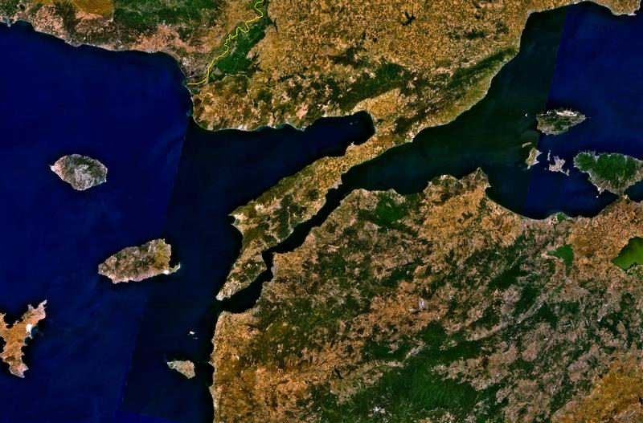

Aegean Sea

Gallipoli peninsula

ANZAC landings

Approx site of
ancient Troy

Turkey

